1. 
2. **Agenda**:
   1. How to create bullet list?
   2. How to combine bullet list with # list and letter list?
   3. How to add checkboxes to make a true “To-Do” list?
3. 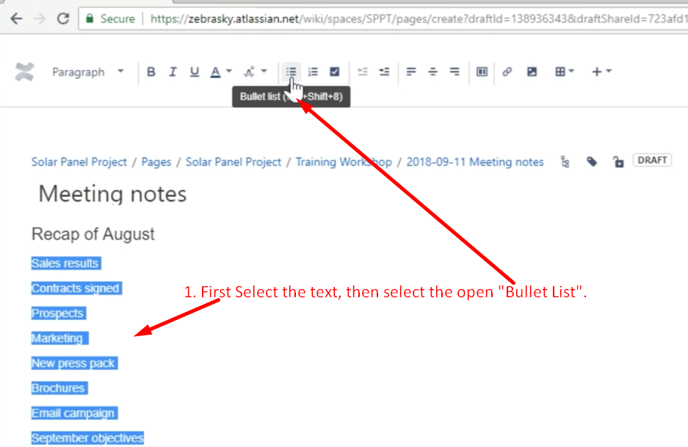
4. 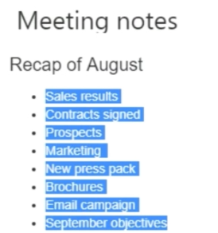
5. 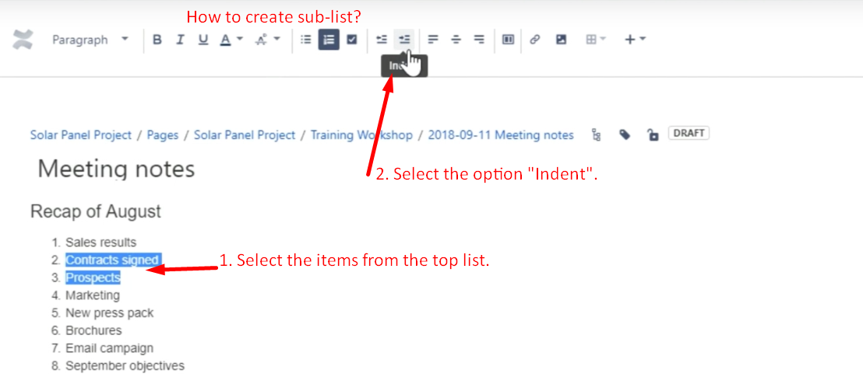
6. 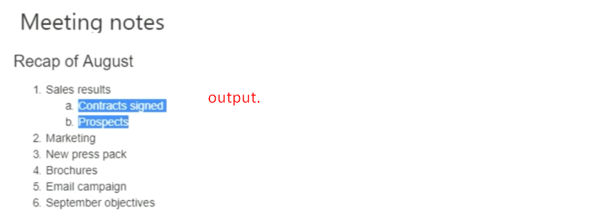
7. 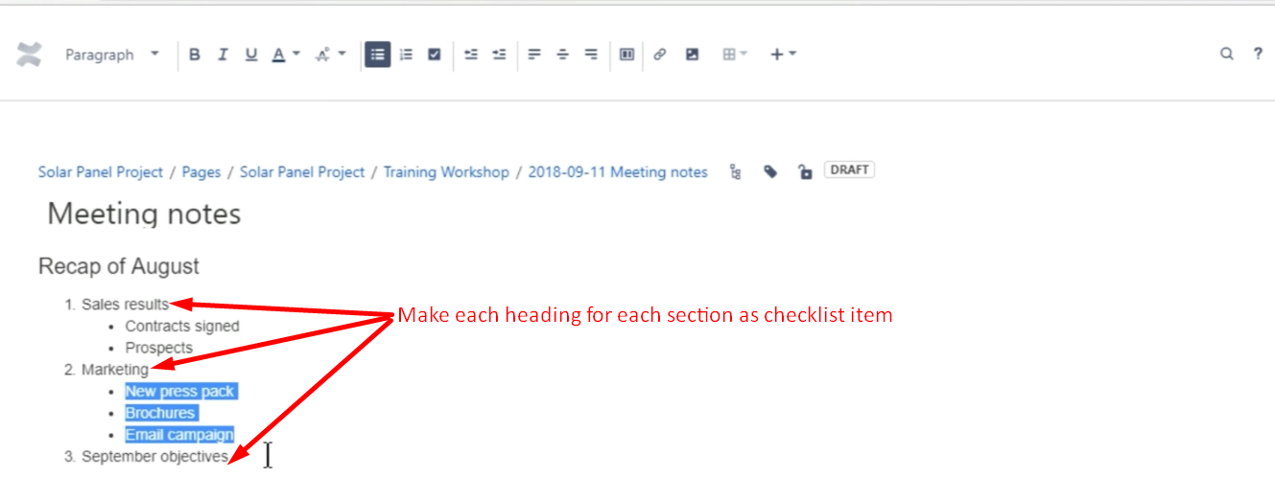
8. 